Kindergarten Massaker

Pitch

Peaceful Alien lands in a Kindergarten. Kids are coming from everywhere. More and more. They tend to surround the Alien and they want “blood”! The Alien has to avoid kids in order to survive. Everything’s seen through a surveillance cam that gets buggier and buggier up to the point that it shuts down. End of game?
Gameplay (more or less)

The game will be a Top Down Shooter in 2D pixel art style.

The game will be in German (just because the title rocks in German).

1 player versus CPU.

1 difficulty level.

One game lasts up to 1 minute (or a bit more with luck as player will become “blind” at some point). Well. As long as the Alien can survive, the game isn’t over but considering that after about 1 minute the screen gets black, I don’t think the game will last very long after that...

The only thing that will be recorded is HOW LONG YOU SURVIVED! (only the best time). We’ll give the length of the game but (if it doesn’t break the record, then) “it’ll be lost for ever like tears in the rain!” This means that we’ll have to write something in a file on the computer… Is that a good idea (probably not)?

Nothing to gather: no bonus, no health, no money, no points, no weapon, no armor, no nothing!

“Contact” with enemies deals no damage, only physical attacks/projectiles/weapons do.

The Alien is invulnerable for the first 2 seconds of the game (and/or after using Second Life talent) “flashing” transparent!
While invulnerable, the alien can’t use his talent...
The Alien

The Aliens have female German old fashioned names: the player’s Alien is called Brünhild, the other one at the teleportation desk is called Gudrun and the Great Tependicular’s name is Hildegard!

The Alien has 1000 hit points (HP).

The Alien has 1 defensive skill to choose (*: visible in the “demo” / **: nothing needed):

- Random teleportation* (cooldown: 10 seconds). Available teleportation points are defined in the Background.tscn.
- Dash* (pass through kids and attacks – cooldown: 15 seconds).
- Repulsive “explosions”* (repulsive effect only on kids – not the ranged attacks – cooldown: 10 seconds).
- Freezing “shock wave”* (Freezes nearby enemies for 4 seconds – not the ranged attacks – cooldown: 15 seconds).
- Quick runner** (runs 20% faster – permanent). It means increasing fps or m/s.
- Force field* (repulsive effect for 6 seconds on ranged attacks – cooldown: 10 seconds).
- Time stop* (affects everything (except the Alien) for 3 seconds – cooldown: 20 seconds).
- Mirror images* (3 invulnerable copies of the Alien appear (“flashing” transparent for 1 frame) and start running in random directions from the player attracting closest kids for 3 seconds then disappear (“flashing” transparent for 1 frame) – cooldown: 15 seconds).
- Dodger** (hit box size reduced by 20% – permanent).
- Invisible* (makes enemies go away as if the Alien wasn’t here for 4 seconds – cooldown: 20 seconds).
- Shield* (invulnerable to hand-to-hand attacks for 3 seconds – cooldown: 10 seconds).
- Second life** (restart with 300 HP from where the Alien died – only 1 time). No teleportation at the restart. The enemies resume doing their things. The alien stays dead for 2 seconds then revive “flashing” transparent for 1 frame.
- Healthy** (20% more hit points – permanent).
- Regeneration** (5 hp per second – permanent).
- Hand to hand specialist** (50% damage from short range but 200% damage from long range – permanent).
- Ranged fighting expert** (50% damage from long range but 200% damage from short range – permanent).
- None!** (permanent!)
- Der Techniker* (hidden talent to unlock (see condition at the end) – only 1 time). Resets the game overlay shader values (and restart its animation!). This allows a longer game leading to more kids...

Shaders are never affected by talents (except for Der Techniker)!

Skill cooldown is shown by the sprite outline color (red means not ready).
No HP shown on screen (we’ll eventually show that also with the outline turning blue).
When hit, the Alien flashes white for 1 frame.
Each skill has its own cooldown (duration depending on the skill as seen above).

Enemies

- Throwing Booger Kids (slow medium ranged explosives with small effect area):
Alien loses 100 HP when hit. Only deals damage after exploding on the ground!

- Spitting Kids (quick short ranged projectile).
Alien loses 50 HP when hit. Disappear before hitting ground (at the end of the animation).

- Kids With Sticks (very quick hand to hand attack).
Alien loses 25 HP when hit.

- Crying Kids run randomly then stop to cry. If the Alien is close enough, that kid will try to kick him. Then resume his routine.
Alien loses 75 HP when hit.

- Vomiting Kids (slow long range attacks with large effect area). Wandering, then vomiting somewhere there’s enough space for the puddle, then resuming… The vomit puddle generate an area that everybody’s running away from.
Alien loses 50 HP per second when walking in the vomit puddle until exiting it. He also takes decreasing damage for up to 2 seconds (35HP the first second, then 15HP) after exiting the area.

- The teacher (see *1 below) running randomly. When close enough to the Alien and kids involved in a fight, tries to stop the mess (she is an obstacle: running then stopping, trying to calm things down staying between kids and Alien).

----------

About “IA”, above is a basic description of the enemy behaviors. In the Pac-Man game, one ghost aims at Pac-Man, another aims ahead of Pac-Man, the third has a random behavior and the fourth ghost tries to reach Pac-Man when close enough. More or less. Maybe we could be inspired by these ideas for our kids.

Every single enemies has a somewhat random size of the detection colliders (+/-10%). Maybe useless?
Technically

Animations at 3s (just like Domestique Baston).

Every game starts from a random point in the area. available spawning points are established before hand (in Background.tscn).

Camera bug effects constantly evolve up to the max after 1 minute or so and the last effect (screen shutdown) always happens just after 1 minute or a bit more… But the game still goes on!

Alien and Enemies have 8 action directions.

Alien animations (left and right are flopped animations, up/left and up/right are flopped animations and down/left and down/right are also flopped animations):
8 Move (run) directions
8 Idle directions
8 Getting Hit directions
8 Death Directions

Enemies (kids) animations (left and right are flopped animations, up/left and up/right are flopped animations and down/left and down/right are also flopped animations):
8 move (run) directions
8 attack directions
8 Idle directions
8 waving directions (when two kids face each other and only in this case, they forget about the Alien and stop running then wave at each other for a couple of seconds then resume moving) – only throwing booger kids, spitting kids, crying kids and kids with sticks.

Teacher animations (left and right are flopped animations, up/left and up/right are flopped animations and down/left and down/right are also flopped animations):
8 Idle directions
8 run directions
8 “stop fighting” directions
OPTION: 8 Waving directions (meaning that she should also follow the kids rule seen just above).

Enemy behaviors:

Followers and stoppers and followers, etc.:
Throwing Booger Kids (run randomly then stop then resume… Until they detect the Alien and then follow him to throw projectile at him but stay in range).
Spitting Kids (run randomly then stop then resume… Until they detect the Alien and then follow him to throw projectile at him but stay in range).
Followers:
Kids With Sticks (run randomly then stop then resume… Until they detect the Alien and then follow him to beat the hell out of him).

Somewhat random:
Vomiting Kids (run randomly then stop to vomit then resume but stay in range).
Crying Kids (run randomly then stop to cry for 2 to 4 seconds and resume… Until the Alien is detected and then try to reach him for a good kicking session (up to 4 attempts then resume…)
Teacher (Stays where she is then runs somewhere else then resume… Until she detects a fight between kids and the Alien and tries to take place between kids and the Alien (eventually) forcing a way between colliders – (see *1 above))

The game starts with 1 Teacher (only 1 per game), 1 Crying Kid, 1 Vomiting Kid, 1 Throwing Booger Kid, 3 Kids with Stick and 2 Spitting Kid spawning randomly on the map.

After 5 seconds of game, every 3 seconds 1 kid spawns in the field (outside of the screen). It doesn’t apply when the Alien dies and until he revives after using Second Life talent:

Chances of spawning:
Spitting Kid: 25%
Kid with Stick: 30%
Throwing Booger Kid: 15%
Crying Kid: 15%
Vomiting Kid: 15%

Kids are running randomly until they detect the Alien (or another kid and are able to wave at each other).

Enemies detection colliders will have a somewhat random size. Useless?

After a kid has dealt damage to the Alien, that kid tends to go away for 3 seconds.

Kids with sticks go away only after hitting the Alien 3 times.

Kids don’t wave while fighting.

Kids are slower than the Alien and the teacher is faster than the Alien.

Just in case it wasn’t obvious, spits, vomit puddles and boogers don’t affect kids and teacher (they avoid those things)!

Kids and teacher avoid vomit puddles nonetheless.

What follows could very be more or less obsolete by the time the project really starts.

Kids with Sticks have 4 colliders:
1 obstacle collider (for background, vomit, other kids, teacher and Alien).
1 Alien detection collider.
1 waving collider.
1 attack collider.

Spitting Kids have 4 colliders:
1 obstacle collider (for background, vomit, other kids, teacher and Alien).
1 Alien detection collider.
1 waving collider.
1 emitter point for their projectiles.

Throwing Booger Kids have 4 colliders:
1 obstacle collider (for background, vomit, other kids, teacher and Alien).
1 Alien detection collider.
1 waving collider.
1 emitter point for their projectiles.

Vomiting Kids have 2 colliders:
1 obstacle collider (for background, vomit, other kids, teacher and Alien).
1 collider to never unleash a vomit puddle that intersects with the background colliders.

Crying Kids have 4 colliders:
1 obstacle collider (for background, vomit, other kids, teacher and Alien).
1 collider to detect if they are close enough to the Alien to start kicking him.
1 waving collider.
1 attack collider.

The Teacher has 2 colliders:
1 obstacle collider (for background, vomit, kids and the Alien).
1 fight detection collider (!).

The Alien has 2 colliders:
1 obstacle collider (for background, kids and the teacher).
1 “get hit” collider.

When a projectile hits the Alien, the projectile flashes white for 1 frame then the projectile disappears.

About screen shaders

The game starts with the basic Screen_Overlay.tscn. It’ll be used everywhere except in game.
When using the Transition screen, if needed, we’ll use it also to cross fade between two different screen overlays.
As all screen overlays use the CRT_2 shader, we’d better extract it from the sets and give him a scene to itself in order to help cross fades (as they use a lot the GPU resources) so that it won’t need to cross fade (it also won’t be animated).
Death.tscn hits without any transition and the Game_Overlay used gets back to its default value (otherwise we won’t be able to read anything).
No transition between menu screens.

The way the values of the shaders evolve through time should follow this curve: CUBIC (or QUART). The point is to have a slow evolution in the beginning of the game (EASE IN).

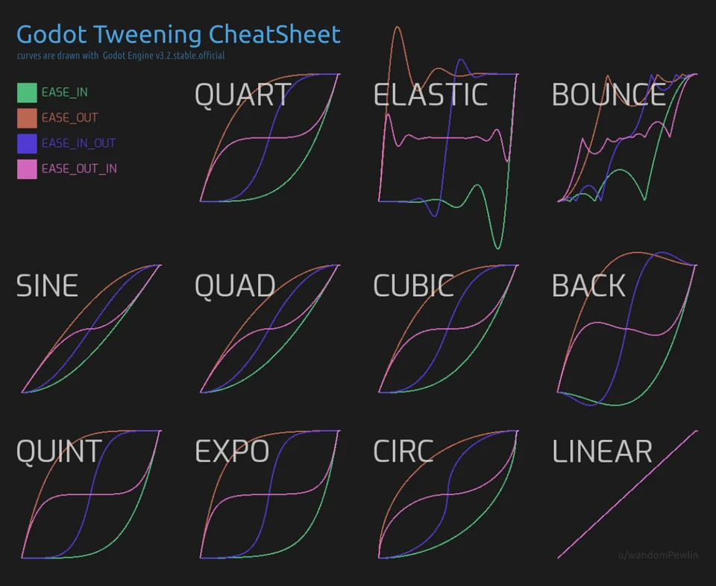
As it is, the transition scene doesn’t cross fades between two playing scenes but between a screenshot of the active scene that will replace the scene and the following scene. That’s not “perfect” (I don’t know how to cross fade between to “active scenes”. Is there even a way to do that without asking too much to the GPU?

“Script” of a game

When starting a game (using the Beam me down, Gudrun! Button), we’ll use the transition screen to go to the game itself. Music will cross fade from music of the menus to the game music while the transition screen plays (starting with INTRO_GAME.wav music then plying in loop the INGAME.wav music).

Death screen will hit without any transition. When hitting the A button on this screen then we’ll use the transition screen again and cross fading music from here back to the game (just as described above). Any other button will bring back the Menu scene (Menu.tscn) with the transition.

About Menus (and hidden talent)

After going one time to the Credits.tscn and back to the previous menu (Menu.tscn) then appears the new (x) option that allows the player to access the Dialogue.tscn.

CONDITIONS to UNLOCK Der Techniker:

Reaching the Shutdown_Overlay.tscn with every single talent unlocks the Der Techniker talent.
OR
Watching Dialogue.tscn entirely allows the access to Der Techniker talent (I’d rather choose this one)!

Shaders

The game overlay (Game_Overlay_1(or 2 or 3).tscn) is randomly selected before the game starts (!).

If time comes, Shutdown_Overlay.tscn is inserted between the game and Game_Overlay_1(or 2 or 3).tscn AND shader values are reset instantly (or in the first 2 frames of the shutdown overlay animation, we’ll test that). Of course, that will depend on how the project is handled in Godot.
A few words about the “demo”

The demo is absolutely irrelevant considering gameplay. In the release version of the game, of course, Background won’t hurt the alien. As is, it’s just a way so make the Death screen appear.
As a matter of fact, there’s nothing like gameplay in it. It’s about showing off what it’s actually graphically looking like, nothing more.

Here’s the text in the Dialogue scene, (heavily) inspired by Alexandre Astier’s Kaamelott:

- Hail Brünhild!
- Hail Hildegard, O great Tependicular of all!
- Brünhild, we need you for a mission of the utmost importance this day, O you, our greatest exosociologist and oncologist (and also rheumatologist) now retired.
- I cannot refuse you anything, O Hildegard, you who taught my son Ursula to read (but not to count).
- Due to a strange disease that, contrary to all expectations, seems to be endowed with a primary form of intelligence, life on this planet is on the verge of extinction. We need to...
- Say no more O Hildegard, I'm going immediately!
Options

Adding 1 more difficulty mode to the normal one: Super Hyper Mega Hardcore (more enemies moving and attacking quickly, nerfed Alien skills, slower Alien, enemies dealing more damage).
Up to 4 Aliens simultaneously (bigger map).
Online mode.
Adding new Aliens would be great.
Adding new skillls.
Adding new enemies (with new behaviors) would be great too.
With a lot of courage, new maps would also be added…
What we borrowed from the world outside:

Assets from Animallogic
Fonts from Iconian Fonts
Sounds from Mixkit.co, Freesound.org, Quicksounds.com
Video shaders by Ahopness (original shaders by: Timothy Lottes, Keijiro, Ehj1, FMS_Cat), Yui Kinomoto, Peter Höglund
Stuff from PlayWithFurcifer, Jon Topielski,

Did we forget something/someone?

